

The Peoples Republic of Bangladesh
Ministry of Health &Family Welfare (Health Service Division)
Health Economic Unit (HEU). Shasta Surakkha Kormochuci (SSK)
Topkhana Road, Dhaka-1000

Visit Report: Bhuapur Upazila Health Complex, Tangail
Date of Visit: 27/07/22 Time: 9:30 AM.
Visitor: Mr. Azmal Kabir, National Consultant (HEU) of MoHFW,
Dr. Md. Emdadul Haque, National Consultant (HEU) of MoHFW&
Mr. Mosharrof Hossain, Program Manager, SSK, Tangail District

1. The UH&FPO of the hospital Dr. Abdus Sobhan was in leave because of COVID-19 positive. We Discussed with RMO, other MOs, nurses and medical technologist (Lab) about the role of the service providers to serve the SSK indoor patients. A PowerPoint presentation, Video on SSK and Building blocks of Chougacha-Jhinaidah Model was presented for them. After the presentations, a question- answer session was held and clarify the role of the individuals.
2. After the meeting, we visited the SSK booth and their activities, learned their challenges and discussed on overcoming the challenges.
3. Then we visited outdoor of Upazila Health Complex. In outdoor, we observed the maternal health service delivery system, quality of maternal health care, their privacy and discussed the role of gynecologist and midwives. We also shared ideas with them regarding health education delivery system, pathology service delivery system and 24/7 blood transfusion system.
4. After that, we visited indoor, labor room and OT of the hospital. We observed the cleanliness of different sections of indoor and toilet management. We observed the cleanliness and quality of standard labor room. We advised them to remove the unwanted items from the labor room. We observed the OT, it was clean and beautiful; but there were some unwanted items which we advised to remove from OT.
5. We visited the emergency department. As previous visit we advised them to improve their instrument sterilization which we found satisfactory in recent visit.
6. We observed the hospital premises. There was a beautiful garden in the premises. But there was no cycle stand close to the main gate of the hospital, that’s why many motor cycle were parked within the hospital corridors. We left the hospital premises at 2 P.M.
8. At 7 P.M. we visited the public library of Tangail District Town and met with the secretary and some of the executive members of that institute. We learned about their opinions regarding SSK in Tangail district and Govt. health service delivery system.
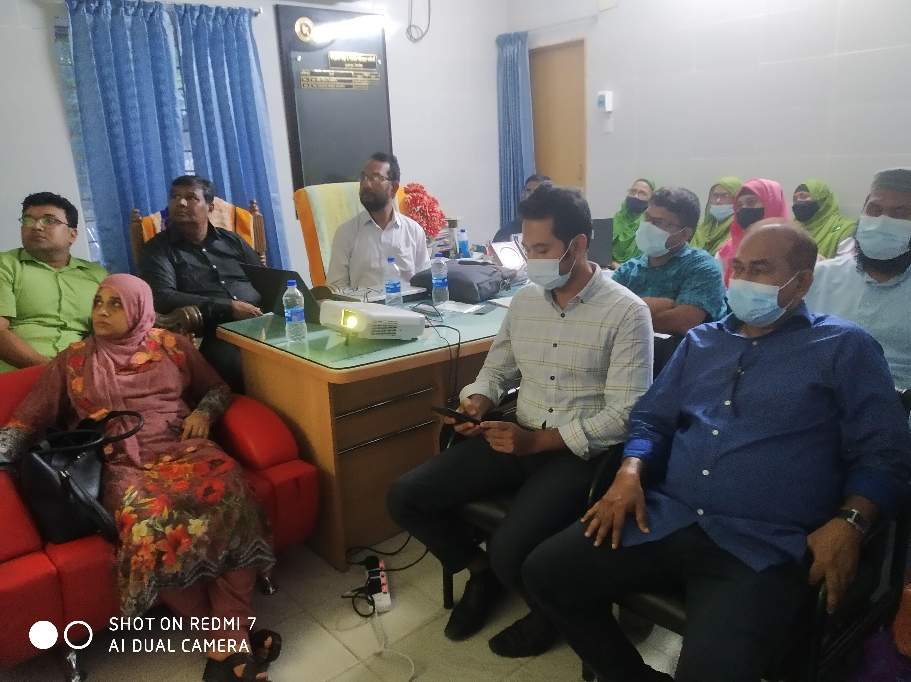

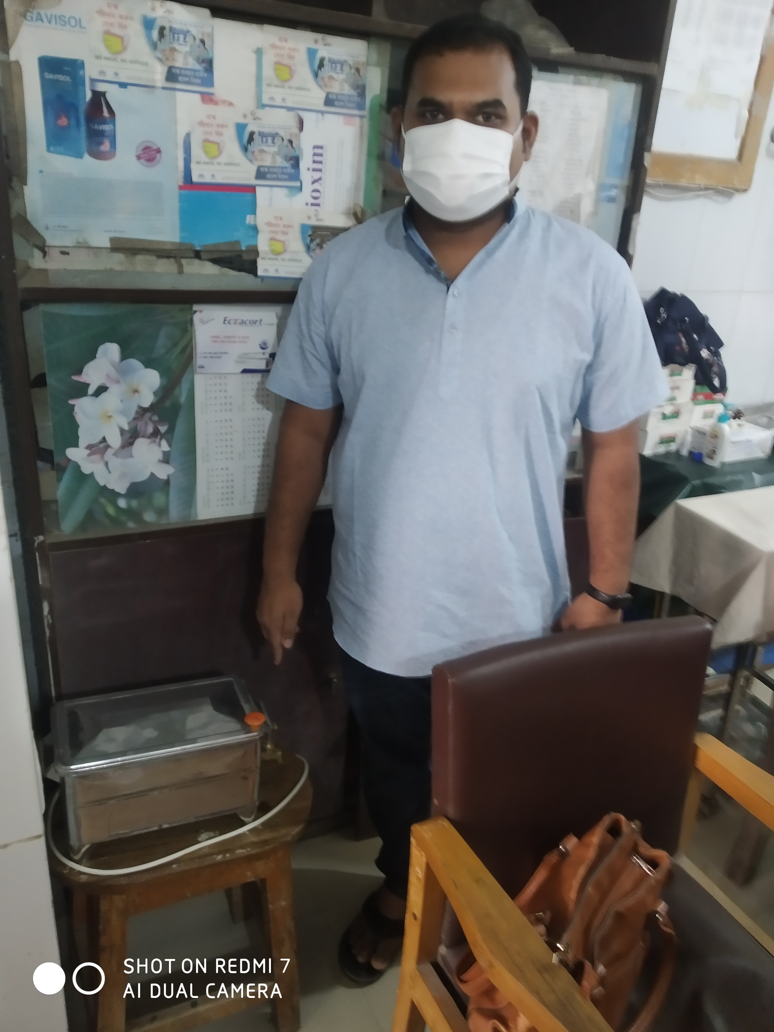
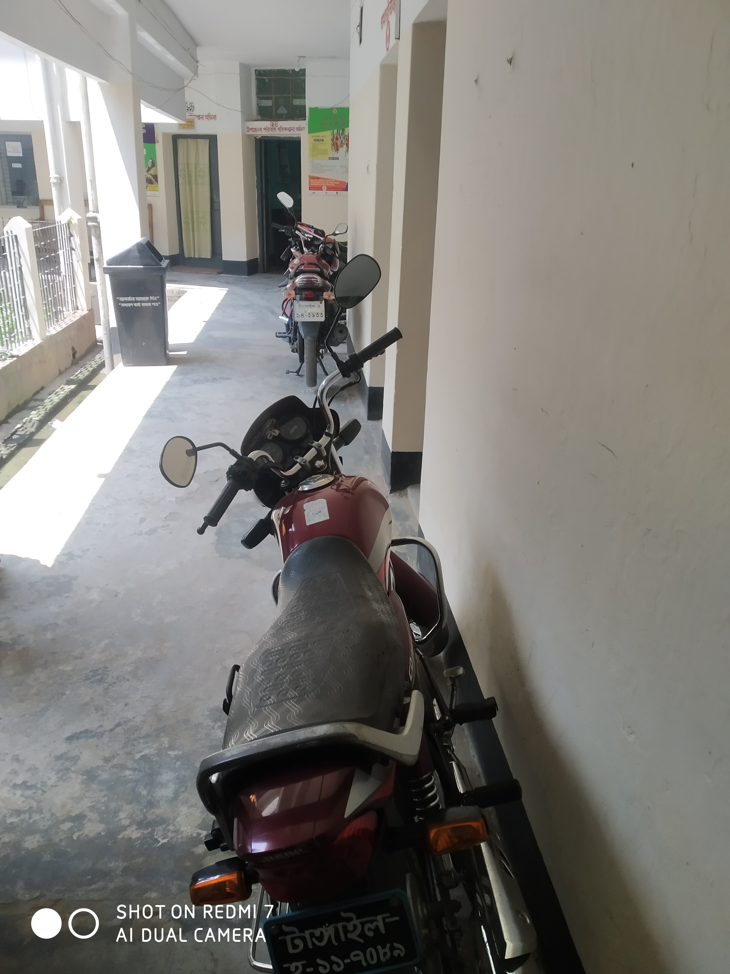
Fig: Meeting with the service providers at Bhuna

Fig: Left- Sterilizer machine in the emergency;
Right- Motorcylcle parked in hospital corridor
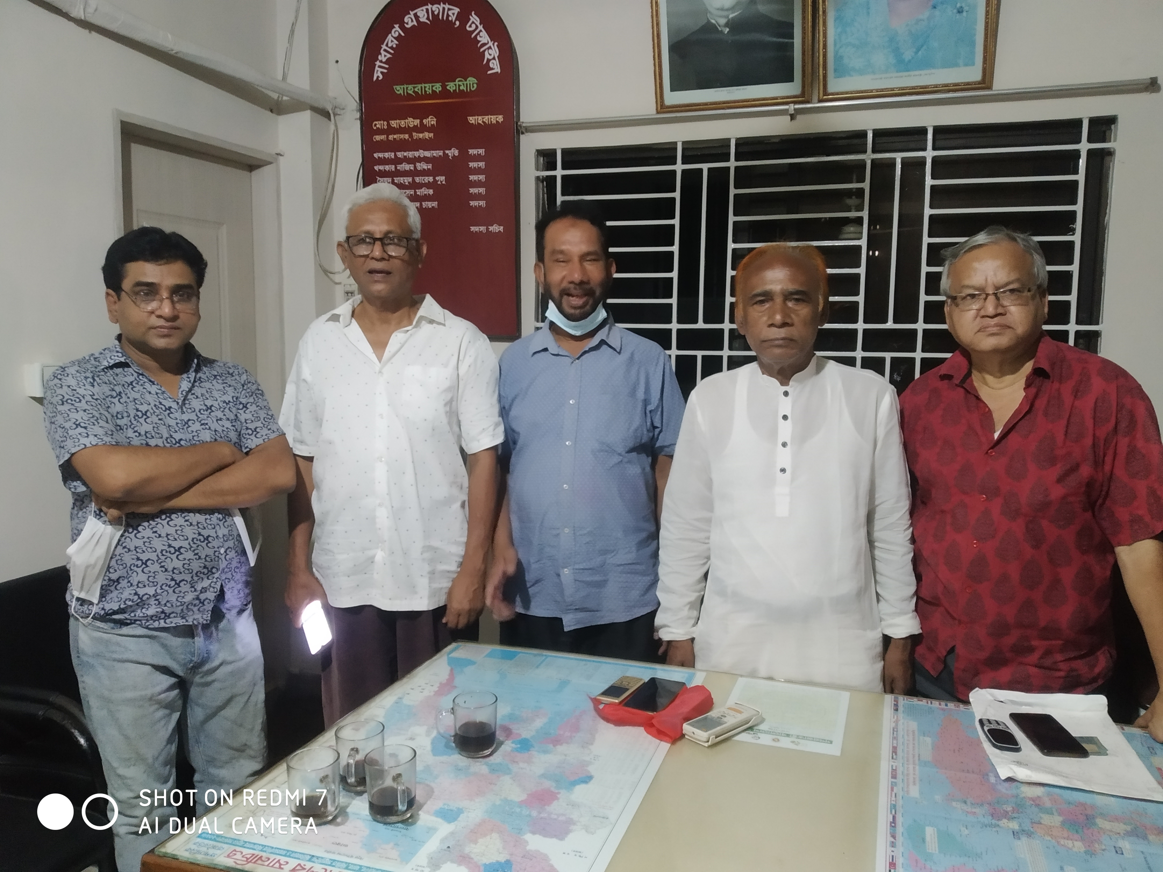

Fig: Meeting with secretary and executive members of Public Library

Visit Report: Tangail District Hospital, Sheikh Hasina Medical College Hospital, Nagorpur Upazila Health Complex, Tangail
Date of Visit: 28/07/22 Time: 8:30 AM.
Visitor: Mr. Azmal Kabir, National Consultant (HEU) of MoHFW,
Dr. Md. Emdadul Haque, National Consultant (HEU) of MoHFW
&
Mr. Mosharrof Hossain, Program Manager, SSK, Tangail District

1. At 8:30am we visited the SSK booth of Tangail district hospital and met with the Superintendent Dr. Sadikur Rahman, RMO Dr. Lutfur Rahman Azad and Dr. Nurul Islam Shamim (Sr. Consultant, Paediatrics). We learned that 33 SSK referred patients was admitted in District hospital on 27 July 2022.
2. We discussed regarding the overall situation of the hospital and it is running well. But the bed occupancy rate was nearly 200%. We requested him to change the SSK booth room because of the room was very small and not well accommodated. He assured us that he will take necessary action as soon as possible regarding this matter.
3. We visited the neonatal unit and labor room. The NICU was excellent and they were managing the room effectively by local initiatives. They are managing it since 2018. The labor room was very small and congested as nearly 4-5 normal delivery is being conducted here every day. Caesarian section was not conducted during night in the hospital.
4. We visited Sheikh Hasina Medical College Hospital at 10am and met with the Director of the medical college hospital Prof. Dr. Mohammad Ali Khan. Outdoor services have been started but indoor service is not yet started because the lack of medical technologist (8-10 in number) and small number of nurses. He assured us immediately he will start the indoor services of the hospital.

5. We visited Nagorpur Upazila Health Complex at 12:30pm. We met with the UH&FPO Dr. Rokonuzzaman. We visited SSK booth and pharmacy of the hospital. We Discussed UH&FPO, other MOs, nurses and medical technologists (Lab) about the role of the service providers to serve the SSK indoor patients. A PowerPoint presentation and Video on SSK and Building blocks of Chougacha, Jhinaidah Model was presented for them. After the presentations, a question Answer session was held and clarify the role of the individuals. RMO was absent as he was in a leadership training in Dhaka.
6. Then we visited the hospital premises. We noticed that a beautiful cycle stand is functioning close to the main gate. It was constructed by HED with the support of Health Economic Unit. We left the hospital at 2:30pm.

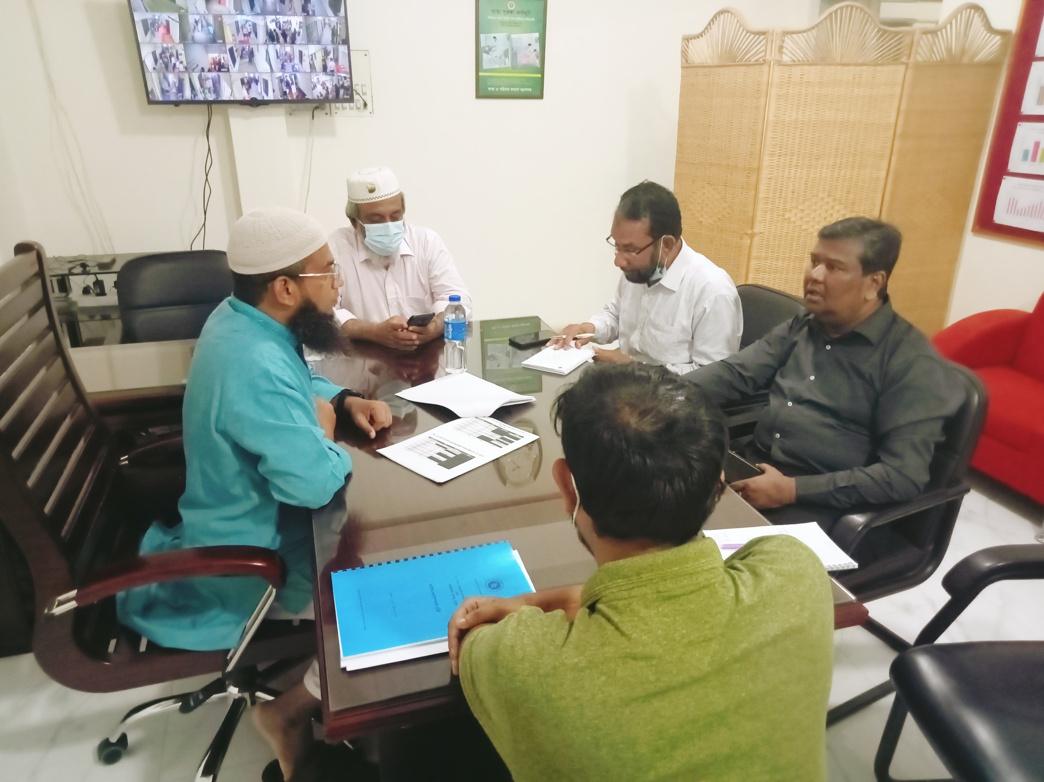

Fig: Discussion with Superintendent, RMO and Senior consultant Pediatrics at
Tangail District Hospital

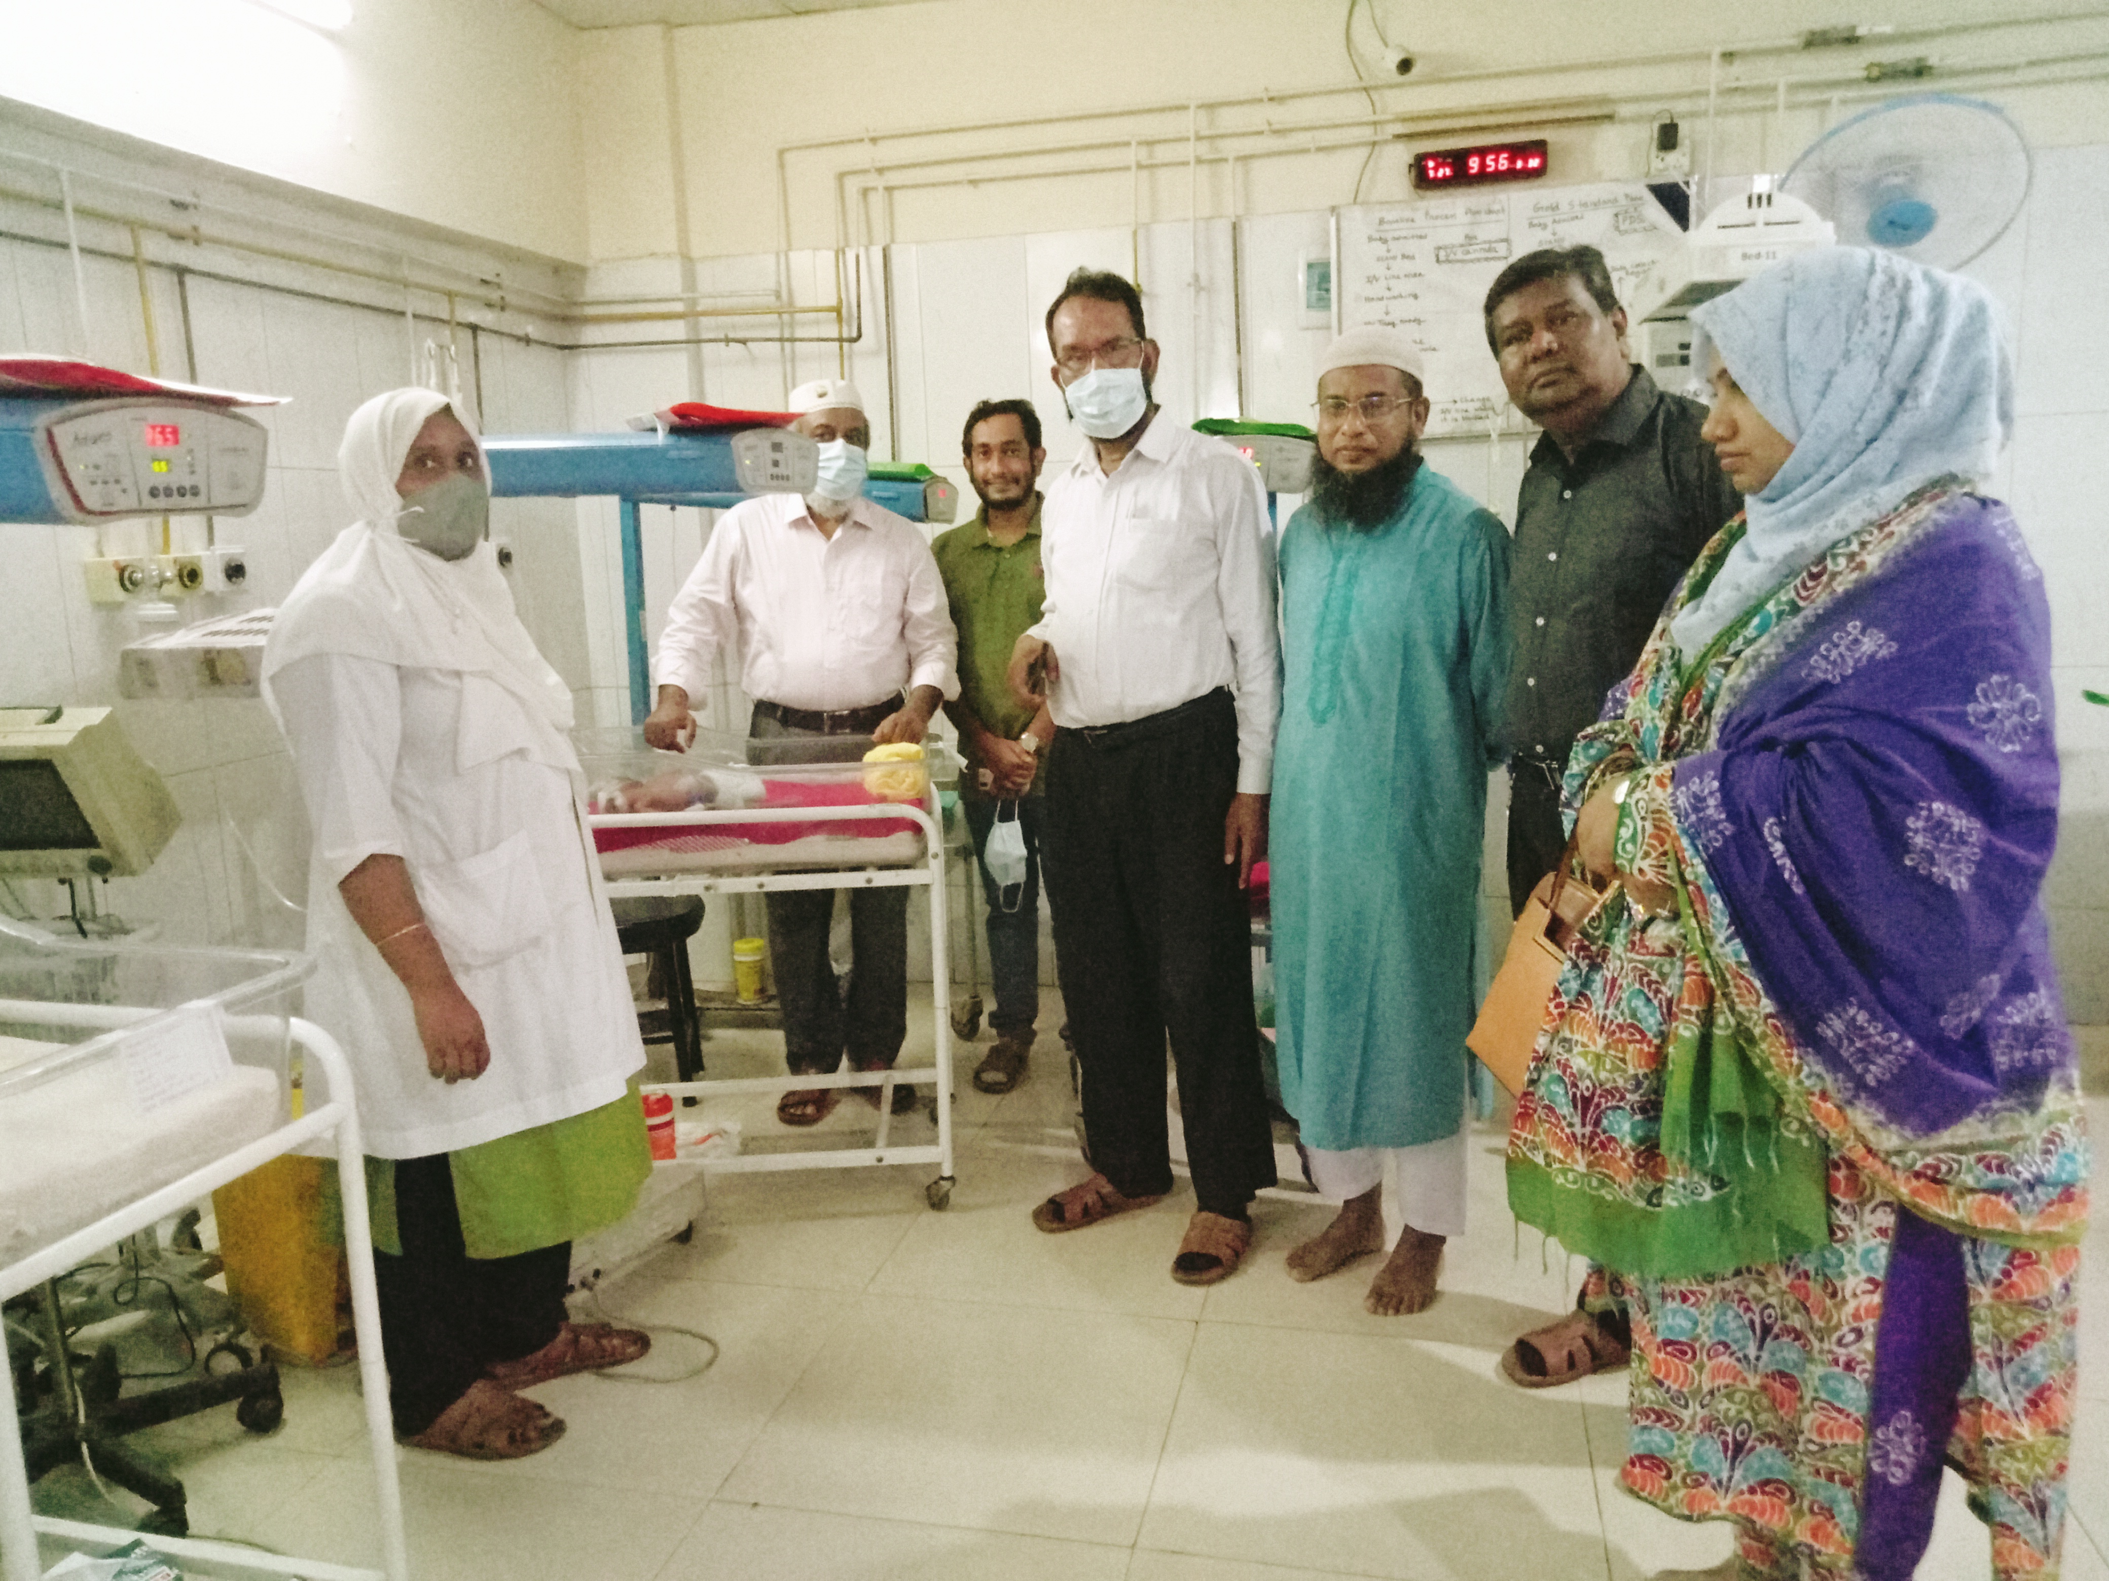

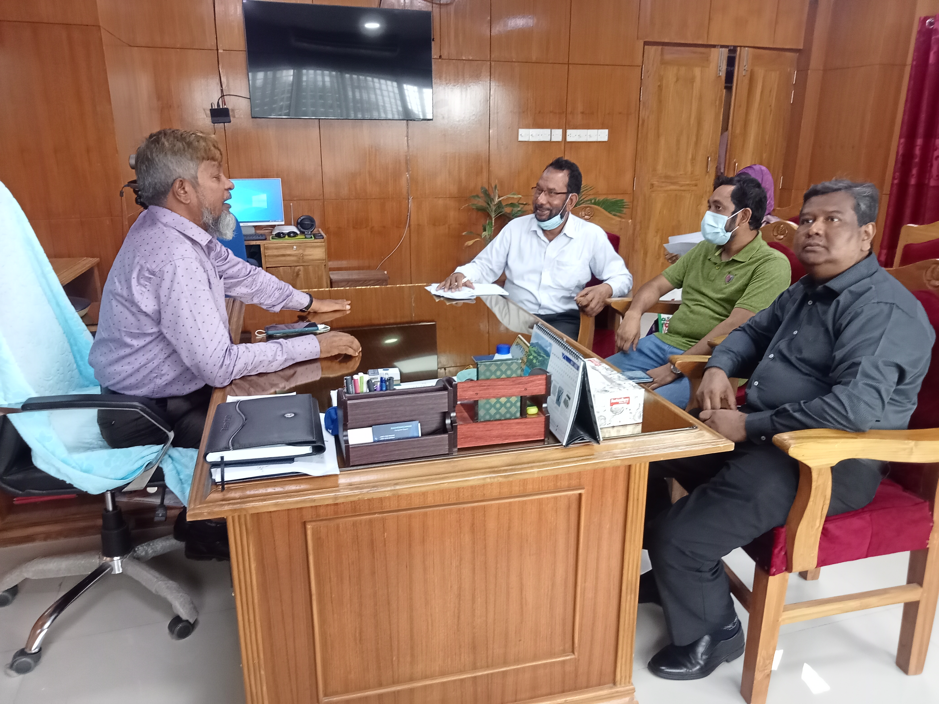
Fig: NICU of Tangail District Hospital

Fig: Discussion with the Director of Sheikh Hasina Medical College Hospital
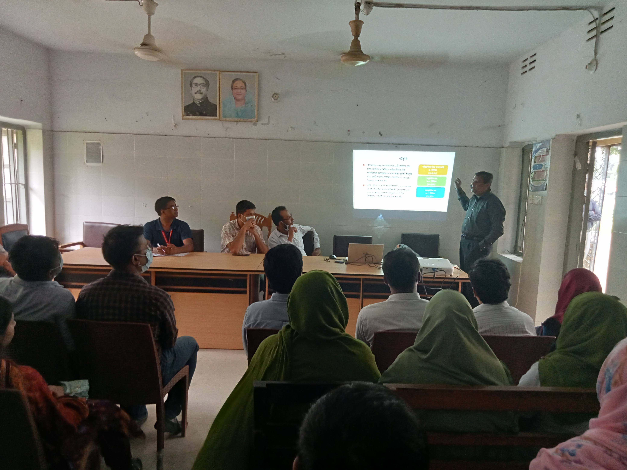

Fig: Meeting with the service providers at Nagorpur UH
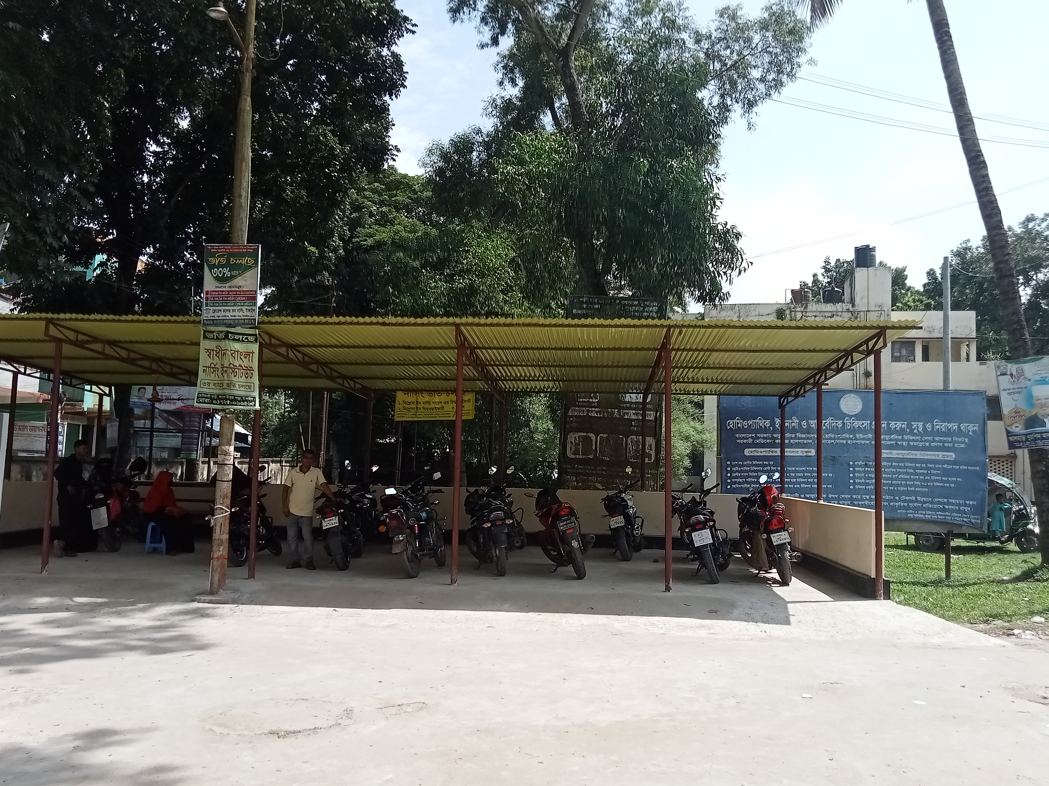

Visit Report: NagorpurUpazillah Health Complex Tangail.
Date of Visit: 18/10/22; Time: 8:15 AM.
Visitor: Dr. Md. Emdadul Haque, National Consultant (SSK) &
Mr. Moshrof Hossain, Program Manager, SSK, Tangail.

We arrived at 8:15 am in the hospital, UH&FPO Dr. Rokunuzaman was present, but many of the service provisers not present in the hospital. SSK booth & Pharmacy was closed at that time. We discussed with UH&FPO about the objectives of our visit. Our objectives of the visit :
1. Discussion meeting with the service provider about building blocks of C-J Model to improve the quality of care.
2. Formation quality improvement commette (QIC)
3.Visit the hospital.
4.Human resourses.
5.Observe the activites of the SSK Program.

1. Discussion meeting: From 9-15 to 10 AM we meet with the service providers (Doctors nurses and technologis & discuss with them by power point presentation about the building blocks of C-J modelsand implementation of those building blocks.
2. Formation quality improvement commette (QIC) according to the guide lines of QIS.and role of the commette.

3. Hospital visit:
a. The hospital gate at the entrance is beautiful. There is a cycle stand close to the main gate but no human resourse to maintain it.There are some unused old billboards which hampers the beautification of the hospital.
b. Emergency is congested, the infection prevention system is weak. The room of EMO is awaya from the emergency dept.
c.There are motor cycles in hospital corridor.
d. There are some unwanted items in storekepers room, MA’s room, X-ray room,
e. There are many corners based effective services and having audio-visual system of health education but no health education corner.
f. There is a vison centre which is very effective.
g. Covid-19 ward is empty & unused.
h. The toilets of indoor are not so clean.
i.The labour ward small and congested.
j. No facility for caesarean section 24/7.
k. The rooftop of the hospital was not clean having some bushes.
l. There is a conference room constructed by the support of SSK.
4.Human resources.
a. Out of 11 posts of junior consultant, 8 posts are vacant. Among them, Medicine, Gynae & Pediatricts are available but no Anestheologist.
There are 2 MT(Lab) is posted but one is deputed in National Parlament Bhabobn.
b. There are two cleaners but no gardener.
c. 5 cleaners and 6 guard supported from SSK.
5 SSK -Services:
a.SSK booth & pharmacy is functioning. 8875 family have got SSK Card.4 patients admitted in the hospital on 16/10/22.
b.The cleaners & guards of SSK are working.But there are many CNG in cmpus.The hospital campus outdoor & indoor was not clean.

Human Resources of 50 Bedded Hospital:
Sl. | Designation | No. of Post | Present | Vacant
1. | UH&FPO | 01 | 01 | 0
2. | RMO | 01 | 01 | 0
3. | Junior Consultant |  | 03 | 07
4. | Medical Officer | 11 | 018 | 07
5. | Medical Officer (OSD) | 08 | 0 | 0
6. | Nurses |  | =32 | 0+1+0+6  =7
8. | Head Assistant | 01 | 01 | 0
9. | Cashier | 01 | 0 | 0
10. | Accountant cum computer operator | 01 | 0 | 0
11. | MT(Dental) | 02 | 01 | 01
12. | MT (Radiology) | 03 | 01 | 02
13. | MT (Lab) | 05 | 02 | 0
14. | MT(TB) | 0 | 0 | 0
15. | Statistician officer | 01 | 0 | 01
16 | Pharmacist | 03 | 02 | 03
17. | Storekeeper | 01 | 0 | 0
18. | Aya | 03 | 01 | 03
19 | Ward Boy | 0 | 01 | 0
20. | MLSS | 05 | 01 | 0
21. | Cleaner | 01 | 02 | 0
22. | Guard | 03 | 06-5 | 03
23. | Gardener | 01 | 01 | 0
24 | Outsourcing: | 11( 6+5) | 0 | 0
25 | Driver | 02 | 02 | 0

Position in HSS Score From Jan-August ( Total UHC-423)
NameUHC | Janu | Feb | Mar | April | May | June | July | August
Modhupur | 73 | 20 | 16 | 07 | 32 | 43 | 41 | 16
Nagorpur | 168 | 212 | 254 | 171 | 204 | 177 | 244 | 259
Sokhipur | 77 | 254 | 91 | 116 | 136 | 148 | 83 | 54

